CHALLENGES ON APP/WEB SERVER

- Install nginx and run nginx on port number 81.
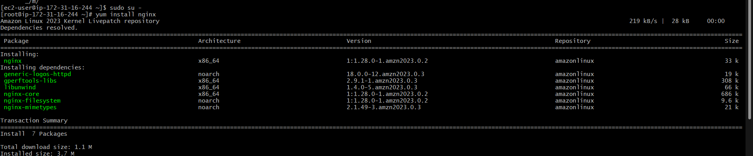
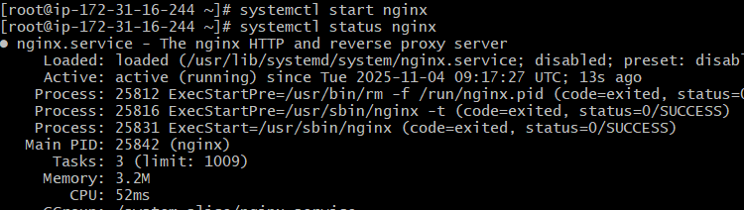
Using vi command to change data
Change to html directory using : cd usr/share/nginx/html/
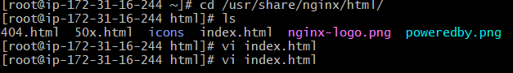
Then edit the file using vi in index.html
Command : vi index.html
And change the details on h1 and verify on browser
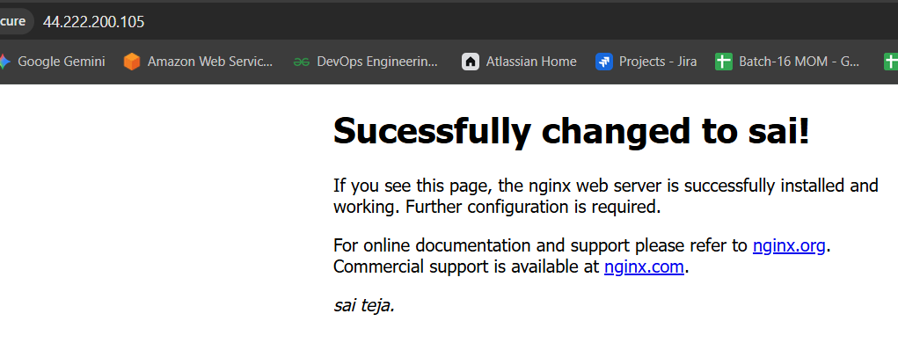
Changing port number
Cat /etc/nginx/nginx.conf to list details
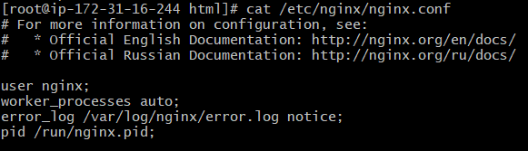
Then vi /etc/nginx/nginx.conf to list details to change
Port number 80 to 81
To verify port number usinf netstat -na | grep 81
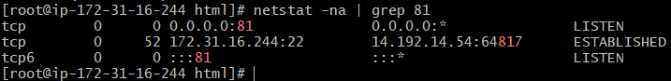
To list all lsof -I tcp:81
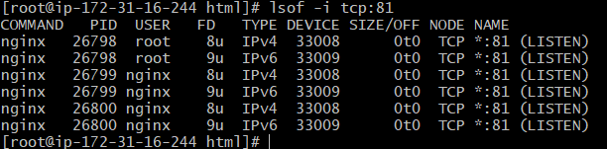
Verify on browser through ip@portnumber
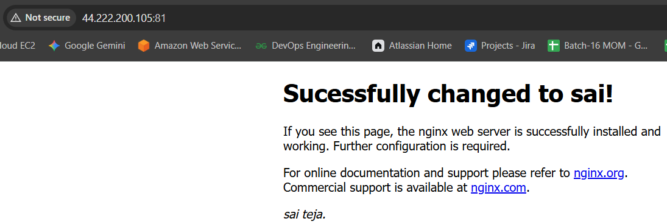

- Deploy a sample index.html file on nginx
Copy a html code from google and paste it under index.html
Cd /usr/share/nginx/html
Then save


- Install Apache and run Apache on port number 82
Apache (called httpd)
Command : yum install httpd -y
Then start the service using
Systemctl start httpd
Verify the port number using netstat -na | grep 82
Or ss tuln command
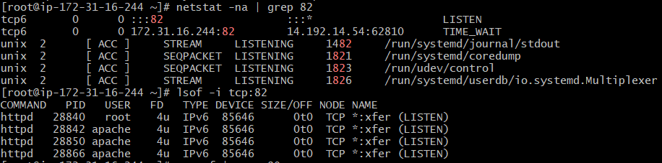

Verify on browser using ipaddress@portnumber
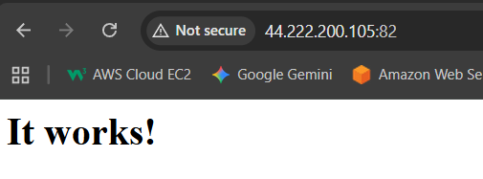

- Install Apache tomcat on port number 8082
Step 1 download link from apache tomcat download
And use Wget command or curl command to run
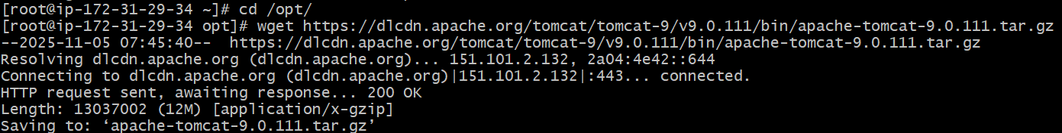

Then list the files using ls and see whether tar.gz file located or not
And use command tar xvf to xtract verbose file
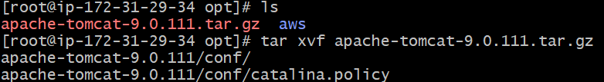
Then change to directory to apache folder
Then list the files
And change to bin
Execute the command ./startup.sh
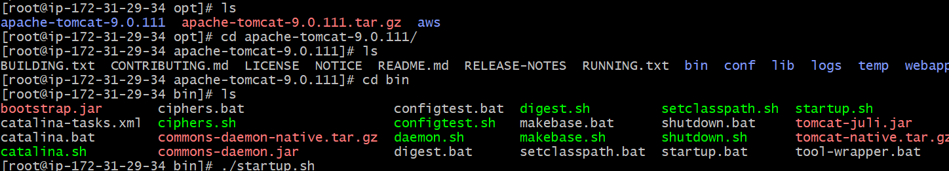
Then check the port using command
Netstat -na | grep 8080
Or ss -tuln
Check in website using ip:8080
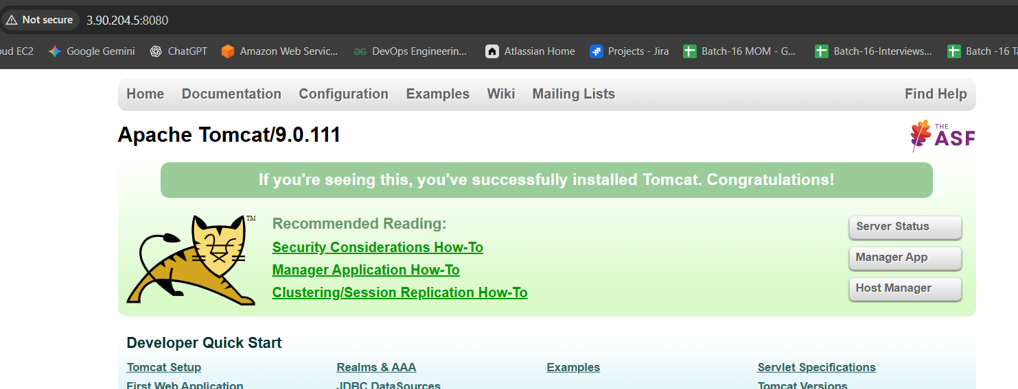
Then change the port number from 8080 to 8082
Step 1 : change directory to cd /opt/
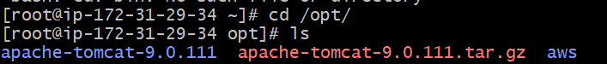
Step2: change directoctory to cd apache-tomcat-9.0.111/
Step3 : change directory to bin/
Step 4: change directory to cd conf/
Step5: edit port number using vi and file called server.x ml and save
Step 6: then use ./shutdown.sh to shutdown the service
Step 7: then use ./startup.sh to restart the service
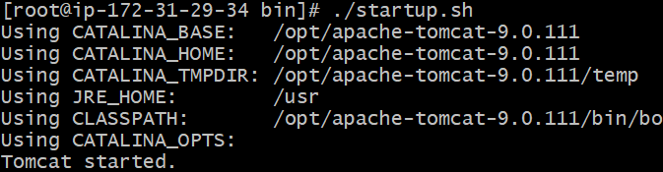
Verifying on browser
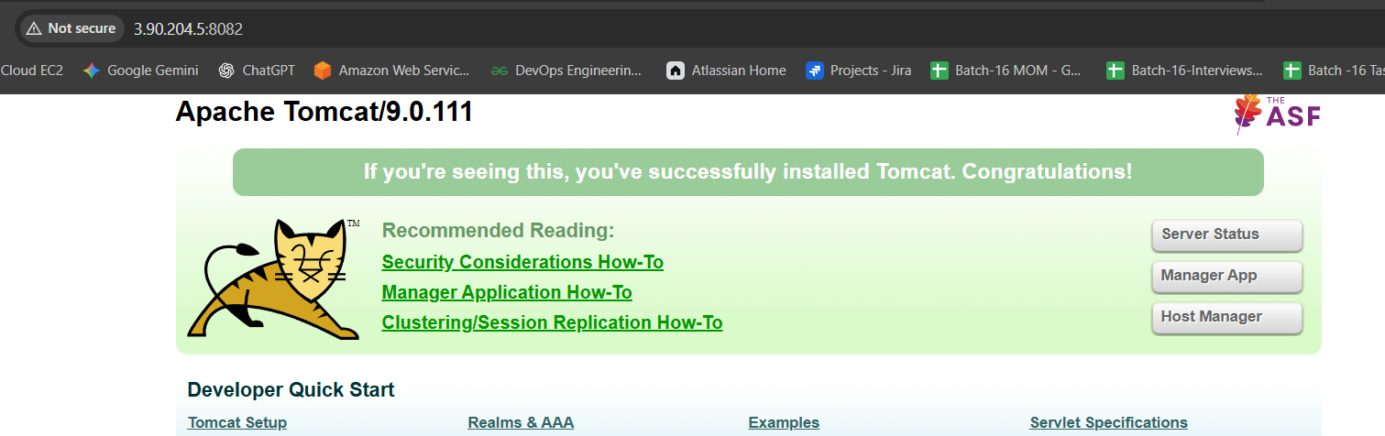
- Deploy a sample app on webapps
Change directory to webapps
cd /opt/apache-tomcat-9.0.111//webapps
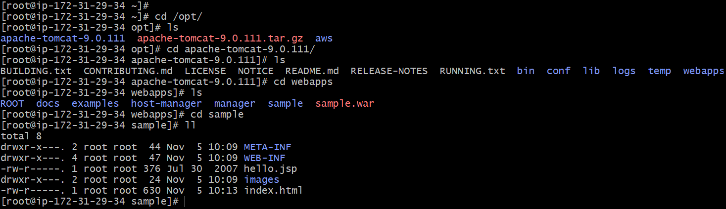

Command : download from google sample.war file
wget https://tomcat.apache.org/tomcat-7.0-doc/appdev/sample/sample.war
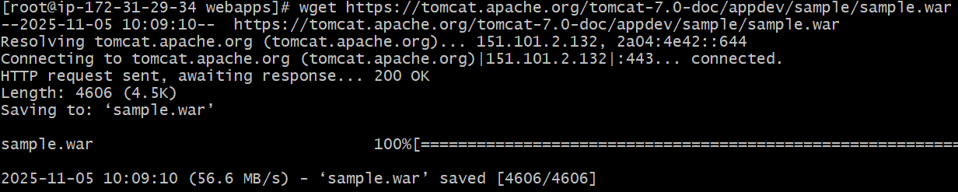

then change directory to sample
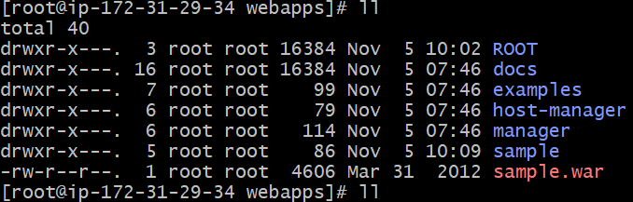
then find index.html file and edit
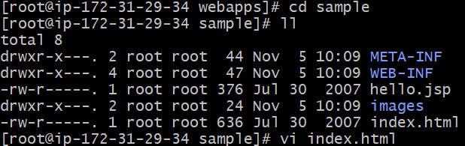
Save
Verify on web add /sample
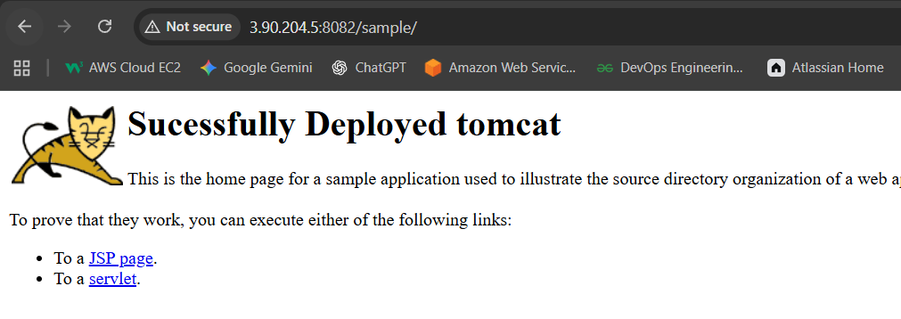

- Create a tomcat.service file for tomcat.
Get code from google and paste it under
Then change the java version as of ur installed java version
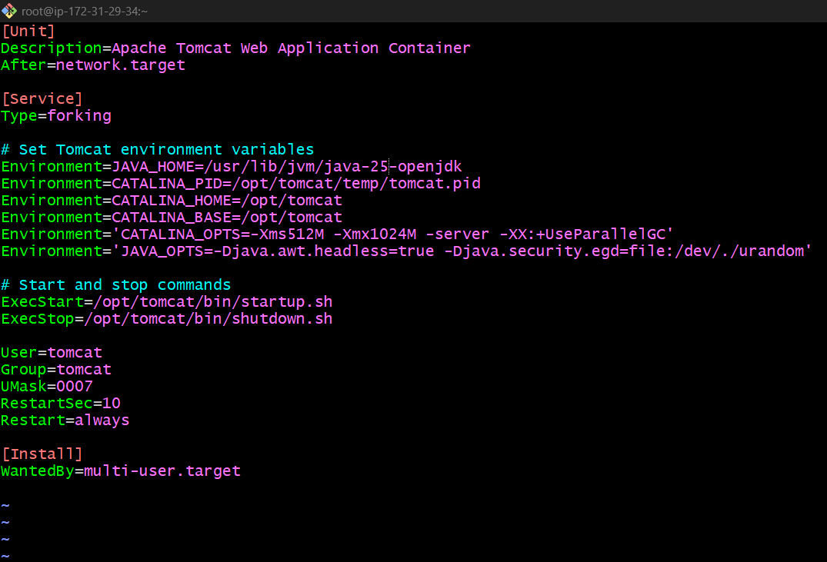
Then save it
Then change ownership of file and root access and
Change permissions to that file
daemon-reload tells systemd to reload all its unit files (like .service, .target, .socket, etc.) from disk.
In simpler terms:
It makes systemd notice new or changed service files — without rebooting.

Then enable tomcat service and check the status
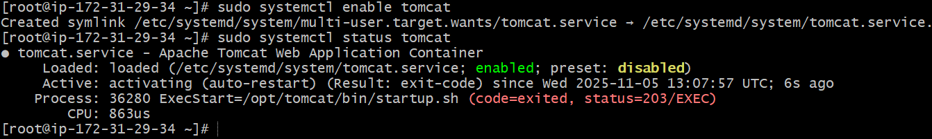

- Configure HA Proxy server
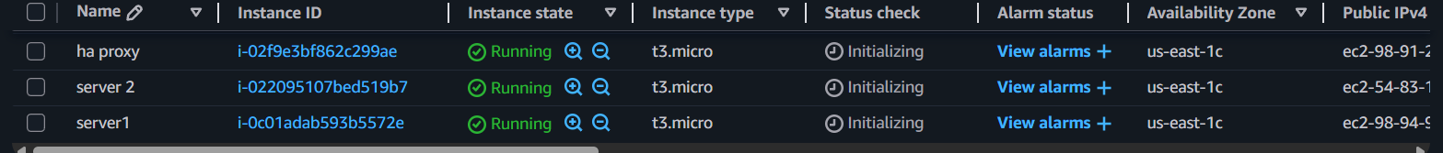

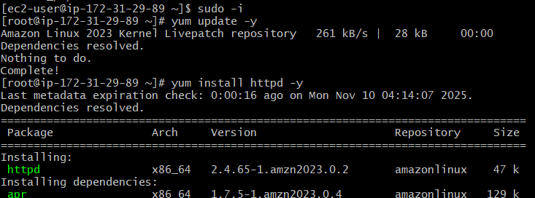

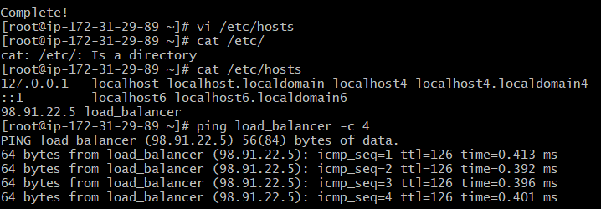

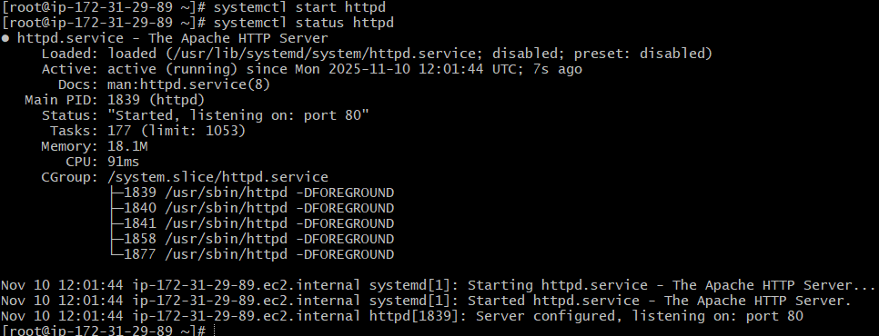
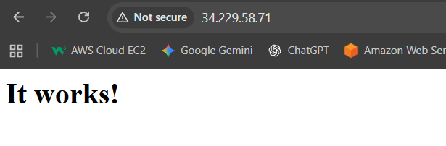

Server 2
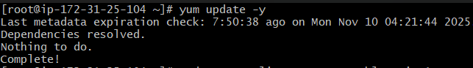
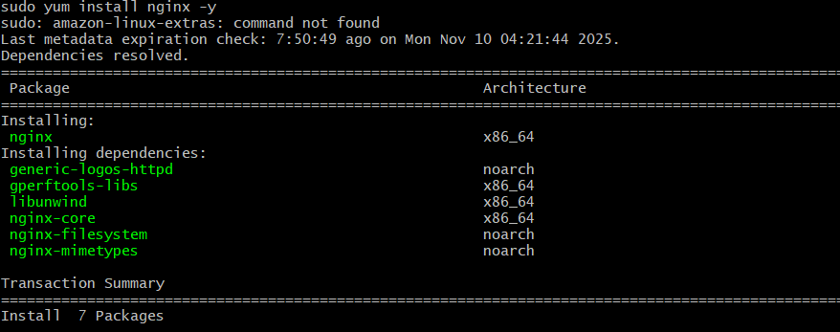
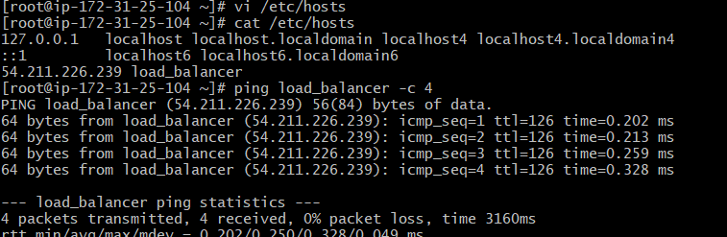

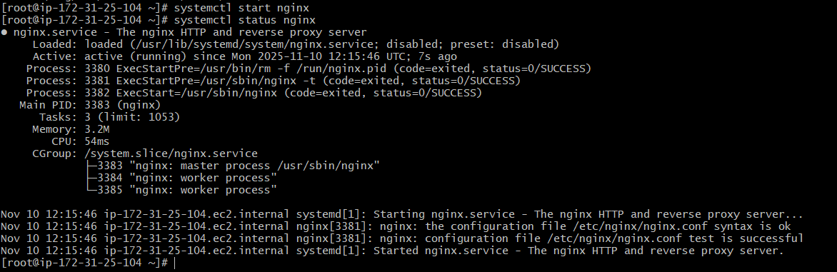
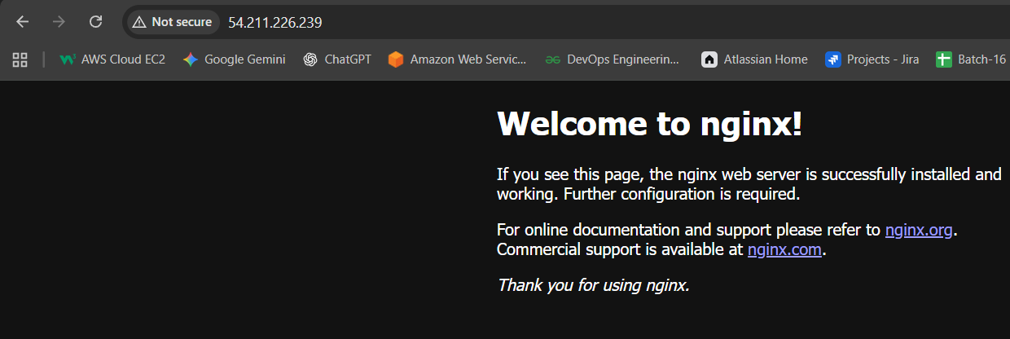

Haproxy:
